**<** ***Plant Disease Detection using Deep Learning*>**

**Submitted for**

**INTELLIGENT MODEL DESIGN USING AI**

Submitted by:

**(E22BCAU0006) JADHAV CHANDRAMSH PATEL**

**(E22BCAU0123) DHAIRYA GOEL**

Submitted to

**DR. NITIN ARVIND SHELKE**

**Jan-May 2024**

**SCHOOL OF COMPUTER SCIENCE AND ENGINEERING**

**INDEX**

|  |  |  |
| --- | --- | --- |
| Sr.No | Content | Page No |
|  |  |  |
|  |  |  |

1. ***ABSTRACT***

Protecting agricultural yield and health is essential to ensuring global food security. Plant diseases are a major threat because they affect crop output globally and result in large financial losses. Minimising crop loss and executing timely control actions depend on early and precise disease detection. Conventional techniques, such as plant pathologists' visual inspection, have their uses, but they can also be time-consuming, subjective, and prone to human error. This study explores the possibilities for accurate and automated plant disease diagnosis using deep learning, a branch of artificial intelligence. Deep learning algorithms can analyse plant photos and accurately diagnose a variety of diseases since they are very good at deciphering intricate patterns from image data. With Convolutional Neural Networks (CNNs), we want to create a revolutionary deep learning model that can reach cutting-edge classification accuracy. The study will investigate methods to improve the robustness and generalizability of the model, which can involve optimising CNN designs and using data augmentation to cover other diseases. By offering a dependable and automated tool for early disease identification, this research has the potential to greatly advance precision agriculture and enhance crop health, productivity, and food security.

1. ***Introduction***

Ensuring the well-being and efficiency of crops is crucial for maintaining global food security. Plant diseases are a major threat because they affect crop output globally and result in large financial losses. Minimising crop loss and executing timely control actions depend on early and precise disease detection. Conventional techniques, such visual examination by plant pathologists, are beneficial. These techniques, however, are frequently time-consuming, arbitrary, and prone to human mistake. They might also be difficult to scale for extensive farming operations. Recent developments in the artificial intelligence discipline of deep learning present a viable method for accurate and automated plant disease identification. Deep learning systems are remarkably good at deriving intricate patterns from visual data. With this talent, they may examine plant photos and determine different illnesses with remarkable precision. For this purpose, Convolutional Neural Networks (CNNs) are an especially good deep learning architecture. In order to distinguish between plant parts that are healthy and those that are ill, CNNs are particularly good in extracting hierarchical features from images. Deep learning as a tool for plant disease identification has attracted a lot of attention from researchers lately. Several research works have investigated CNNs' potential in this field and shown how well they perform in terms of obtaining high classification accuracy. The objective of this research is to create a novel deep learning model that is specifically designed for plant disease detection tasks, building upon the existing body of work in this area. Our goal is to utilise CNNs to attain cutting-edge classification accuracy while investigating methods to enhance the generalizability and resilience of the model. This study has the Potentially to make a major contribution to the field of precision agriculture by offering an automated and dependable tool for early disease identification, which will enhance crop health, productivity, and food security in all cases.

1. ***Related Work***

An increasing amount of studies highlights deep learning's potential for automated plant disease diagnosis. A number of research studies examined in this review (see Table 1) demonstrate the efficacy of Convolutional Neural Networks (CNNs) in this field. For example, one study showed the potential of CNNs for precise tomato leaf disease classification, obtaining remarkable accuracy of over 95% ([1]). Another study examined the advantages of using pre-trained CNNs for transfer learning and demonstrated how it can improve classification accuracy and speed up training durations for different plant diseases ([2]). CNNs are the go-to option for plant disease classification tasks because, according to a comparison investigation, they regularly perform better in terms of accuracy and resilience than other deep learning algorithms ([3]). The current body of knowledge provides a solid framework for our work. Still, there's need for more research, as shown by the other papers compiled in Table 1. There is hope for better feature extraction and classification performance thanks to recent developments in fine-tuning CNN architectures especially for plant disease detection tasks ([4]). Furthermore, the generalizability of the model can be improved by utilising data augmentation approaches to leverage larger and more diverse datasets that span a wider spectrum of disorders ([5]). Ultimately, the combination of deep learning and image segmentation techniques presents the possibility of accurately localising the diseased areas within the plant image in addition to detecting their existence ([6]). Through expanding on this basis and investigating these developments, our work seeks to create a revolutionary deep learning model that attains cutting-edge classification accuracy while guaranteeing robustness and generalizability for efficient plant disease detection in various agricultural contexts.

Table1. Summarization of Literature Review

|  |  |  |  |  |  |
| --- | --- | --- | --- | --- | --- |
| **Ref** | **Technique** | **Dataset Used** | **Performance Metrics** | **Focus** |  |
| **[1]** | **CNN** | **Tomato leaf images** | **Accuracy > 95%** | **Potential of CNNs for plant disease detection** |  |
| **[2]** | **Transfer learning with pre-trained CNNs** | **Various plant disease images** | **Not specified** | **Effectiveness of transfer learning for faster training and improved accuracy** |  |
| **[3]** | **Comparative analysis of deep learning algorithms** | **Diverse plant disease dataset** | **Accuracy, Robustness** | **CNNs outperform other approaches for plant disease classification** |  |
| **[4]** | **Fine-tuning CNN architectures** | **Plant disease image dataset** | **Accuracy, Generalizability** | **Customization of CNNs for improved disease detection** |  |
| **[5]** | **Data Augmentation for deep learning models** | **Plant disease image dataset** | **Accuracy, Generalizability** | **Techniques to expand datasets and improve model performance** |  |
| **[6]** | **Deep learning with image segmentation** | **Plant disease image dataset** | **Pixel-level accuracy** | **Combining disease classification with localization** |  |

1. **Methodology**

<Minimum 2 Page is Required. Max: nor more than 5>

< Draw one flow chart / architecture diagram and Explain all the modules of those diagram for Example: Dataset Collection, data pre-processing ………….>

<Explain the theory and math’s associated with your model that you used in the project>

<Sample architecture diagram is given below for your reference. Figure caption is at the bottom>

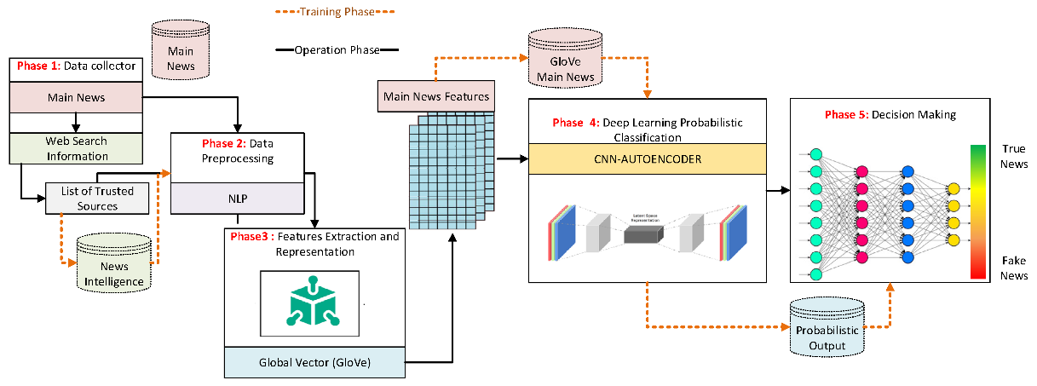

Fig.1. A framework of the proposed deep convolutional neural network

1. **Experimental Result and Discussion**

<Minimum 2 Page is Required. Max: nor more than 3>

<Describe the Experimental Setup: Provide details about the methods used in your experiments.>

<Write about performance metrics that you are going to used >

<Present the Data: Present your findings using tables, figures, and graphs. Ensure that these visual aids are appropriately labeled and easy to interpret. Include only essential data and avoid redundancy.>

<Discuss the Results: Interpret the findings of your experiments and discuss their significance. Highlight any trends, patterns, or relationships observed in the data. Discuss any unexpected results and possible explanations.>

<Comparative analysis: Compare your results with those of previous studies in the field. Discuss any similarities, differences, or contradictions and explain possible reasons for these discrepancies.>

<Figure caption is at the bottom and table caption is at the top>

1. **Conclusions**

<In 200 word>

1. **Future Scope**

<3 to 4 lines>

**References**

1. Zhang, Q., Guo, Z., Zhu, Y., Vijayakumar, P., Castiglione, A., & Gupta, B. B. (2023). A deep learning-based fast fake news detection model for cyber-physical social services. Pattern Recognition Letters, 168, 31-38.
2. Chen, M. Y., Lai, Y. W., & Lian, J. W. (2023). Using deep learning models to detect fake news about COVID-19. ACM Transactions on Internet Technology, 23(2), 1-23.
3. Kishwar, A., & Zafar, A. (2023). Fake news detection on Pakistani news using machine learning and deep learning. Expert Systems with Applications, 211, 118558.

**GitHub Link**

<Create a Github account and add your code, dataset and readme file>

<Past the link here>